# Flynn's Classification of Computers

M.J. Flynn American professor emeritus at Stanford University. proposed a classification for the organization of a computer system by the number of instructions and data items that are manipulated simultaneously.

Flynns classification depends on Data stream and Instruction stream.

The term stream refers to the flow of instruction or data.

The sequence of instructions read from memory constitutes an **instruction stream**. It is within the fetch and execution of data stream by the machine.

A data stream is the operations performed by the processor on data.

Flynn's classification divides computers into four major groups that are:

1. Single instruction stream, single data stream (SISD)
2. Single instruction stream, multiple data stream (SIMD)
3. Multiple instruction stream, single data stream (MISD)
4. Multiple instruction stream, multiple data stream (MIMD)

SISD

**SISD** stands for ***'Single Instruction and Single Data Stream'***. It represents the organization of a single computer containing a control unit, a processor unit, and a memory unit. It is a uniprocessor machine that is capable of executing a single instruction operating on a single data stream.

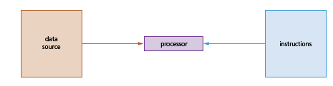

Most conventional computers have SISD architecture where all the instruction and data to be processed have to be stored in primary memory.

* Single instruction: Only one instruction stream is being acted or executed by CPU during one clock cycle.
* Single data stream: Only one data stream is used as input during one clock cycle.

Instructions are decoded by the Control Unit and then the Control Unit sends the instructions to the processing units for execution. Data Stream flows between the processors and memory bi-directionally.

**SISD:** A classical Von Neumann  computers comes under this categories.

* It has one instruction stream one data stream.
* It does one thing at a time.
* It has capability of manipulating one data stream at a time by executing a single instruction stream.

# SIMD

**SIMD** stands for *'Single Instruction and Multiple Data Stream'*. SIMD architecture involves multiple processing units that operate in parallel, executing the same instruction on multiple pieces of data simultaneously.

All processors receive the same instruction from the control unit but operate on different items of that data. The shared memory unit must contain multiple modules so that it can communicate with all the processors simultaneously

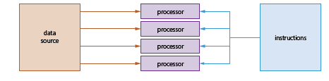

This architecture is especially efficient for tasks that can be parallelized, such as multimedia processing and scientific simulations.

Graphics processing units (GPUs) often use SIMD architecture to process pixel data simultaneously.

**Characteristics**

[SIMD](https://easyexamnotes.com/multivector-and-simd-computers/): [SIMD](https://easyexamnotes.com/multivector-and-simd-computers/) computers have single instruction stream to execute on multiple data stream.

* It has a single control unit to generate one instruction stream at a time.
* A single control unit have multiple ALUs (Arithmetic and logic units) to work on multiple data streams simultaneously.
* It has capability to execute a single instruction stream on multiple data streams.
* Its also known as vector or array processors machine.
* In [SIMD](https://easyexamnotes.com/multivector-and-simd-computers/) multiple processing units are supervised by a single control unit.

SIMD is mainly dedicated to array processing machines. However, vector processors can also be seen as a part of this group

# MISD

MISD **'Multiple Instruction and Single Data stream'**. architecture involves multiple processing units, each executing different instructions on the same data stream. While theoretically possible, practical applications of MISD architecture are very limited and rare.

In MISD, multiple processing units operate on one single-data stream. Each processing unit operates on the data independently via separate instruction stream

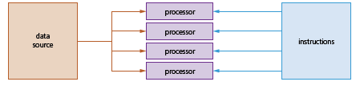

It has multiple instruction stream, which operate on same data stream. The output of one processor become the input of next processor.

# MIMD

**MIMD** stands for **'Multiple Instruction and Multiple Data Stream'**.

MIMD architecture has multiple processors that independently execute different instructions on different data streams. This category includes modern multi-core processors, distributed computing systems, and parallel computing clusters.

Each processor can execute its own program independently, making MIMD systems highly versatile for various tasks.

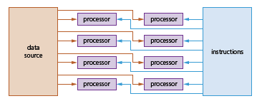

Each processor has a separate program and an instruction stream is generated from each program.

When carrying out parallel processing, processors need to be able to communicate. The data which has been processed needs to be transferred from one processor to another. When software is being designed, or programming languages are being chosen, they must be capable of processing data from multiple processors at the same time.

It is a much faster method for handling large volumes of independent data; any data which relies on the result of a previous operation (dependent data) would not be suitable in parallel processing. Data used will go through the same processing, which requires this independence from other data.

Parallel processing overcomes the Von Neumann ‘bottleneck’ (in this type of architecture, data is constantly moving between memory and processor, leading to latency; as processor speeds have increased, the amount of time they remain idle has also increased since the processor’s performance is limited to the internal data transfer rate along the buses). Finding a way around this issue is one of the driving forces behind parallel computers in an effort to greatly improve processor performance.

However, parallel processing requires more expensive hardware. When deciding

whether or not to use this type of processor, it is important to take this factor

into account.